Breakfast Comparison
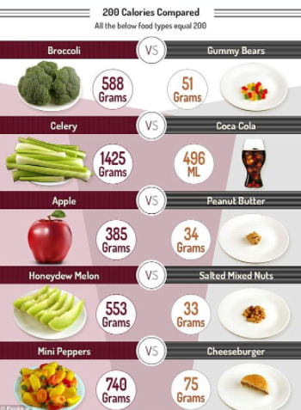
NUTRIENT DENSITY
- Nutrient dense foods give you the most nutrients for the fewest amount of calories.
- Nutrient dense foods give you the "biggest bang for the buck." You get lots of nutrients, and it doesn't cost you much in terms of calories
- No principle is more likely to support healthy eating than the principle of nutrient density.

